Experiment 4

Student Name: Kaushik UID: 24BAI70562
Branch: CSE - AIML Section/Group: 24AIT_KRG G1
Semester: 4 Date of Performance: 4/2/26
Subject Name: DBMS Subject Code: 24CSH-298

Aim
To design and implement PL/SQL programs utilizing conditional control statements such as IF–ELSE, ELSIF, ELSIF ladder, and CASE constructs in order to control the flow of execution based on logical conditions and to analyse decision-making capabilities in PL/SQL blocks.

Software Requirements
- Database Management System:
  - PostgreSQL
- Database Administration Tool:
  - pgAdmin

Objectives
- Implement control structures in PL/SQL (IF-ELSE, ELSE-IF, ELSE-IF LADDER, CASE STATEMENTS in PL-SQL BLOCK).

Problem Statement
Develop and execute PL/SQL programs that demonstrate the use of conditional control statements. The programs should employ IF–ELSE, ELSIF, ELSIF ladder, and CASE statements to evaluate given conditions and control the flow of execution accordingly, thereby illustrating decision-making capabilities in PL/SQL blocks.

- Problem Statement – IF–ELSE Statement
Write a PL/SQL program to check whether a given number is positive or non-positive using the IF–ELSE conditional control statement and display an appropriate message.

- Problem Statement – IF–ELSIF–ELSE Statement
Write a PL/SQL program to evaluate the grade of a student based on the obtained marks using the IF–ELSIF–ELSE statement and display the corresponding grade.

- Problem Statement – ELSIF Ladder
Write a PL/SQL program to determine the performance status of a student based on marks using an ELSIF ladder and display the appropriate result.

- Problem Statement – CASE Statement
Write a PL/SQL program to display the name of the day based on a given day number using the CASE conditional statement.

Practical/Experiment Steps
- Control Structure Implementation: Designed multiple PL/SQL blocks to explore diverse conditional logic formats, including simple branching and multi-path evaluation.
- Logic Branching Analysis: Utilised IF-ELSE and ELSIF ladders to categorize numerical data into specific ranges, such as student grades and performance statuses.
- Selection Optimisation: Implemented the CASE statement as a streamlined alternative to multiple conditional checks for mapping discrete values like day numbers to names.
- Dynamic Messaging: Integrated variable-driven output strings to provide real-time feedback based on the evaluation of input conditions.
- Execution Flow Control: Validated the decision-making capabilities of the PL/SQL engine by testing various input scenarios to ensure the correct code path was activated.

Procedure
- Enabled the output server environment to ensure all procedural results would be visible in the console window.
- Constructed a basic IF-ELSE block to perform a binary check on a numerical variable for positive or non-positive properties.
- Developed an IF-ELSIF-ELSE structure to map student marks to specific letter grades based on defined percentage thresholds.
- Expanded the conditional logic into a comprehensive ELSIF ladder to categorise performance into tiers such as Distinction, First Class, and Pass.
- Implemented a CASE statement block to translate integer inputs into corresponding day names, including a default handler for invalid entries.
- Initialised diverse test values for each variable, such as negative numbers for sign checks and specific marks for grading, to verify logic accuracy.
- Nested the procedural logic within standard BEGIN...END; blocks to maintain structured programming principles.
- Executed each individual block sequentially and monitored the DBMS output console for the expected string concatenations.
- Verified that the output correctly reflected the logic branch associated with the assigned variable values and documented the results.
- Verified the console output against the manual calculations to ensure the logic and variables were handled correctly.

Input/Output Analysis
SQL Input Queries
DECLARE
NUM NUMBER:=-69;

BEGIN
IF NUM>0 THEN
DBMS_OUTPUT.PUT_LINE('IT IS A POSITIVE NUMBER');
ELSE
DBMS_OUTPUT.PUT_LINE('IT IS A NON-POSITIVE NUMBER');
END IF;
END;

Output
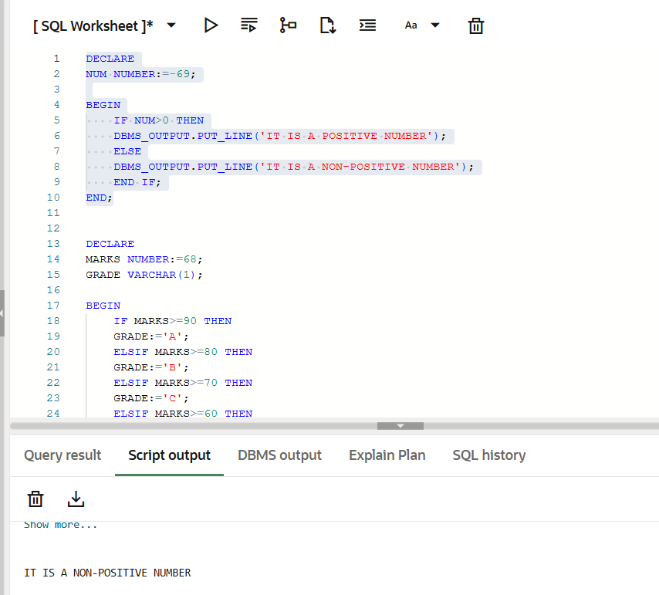
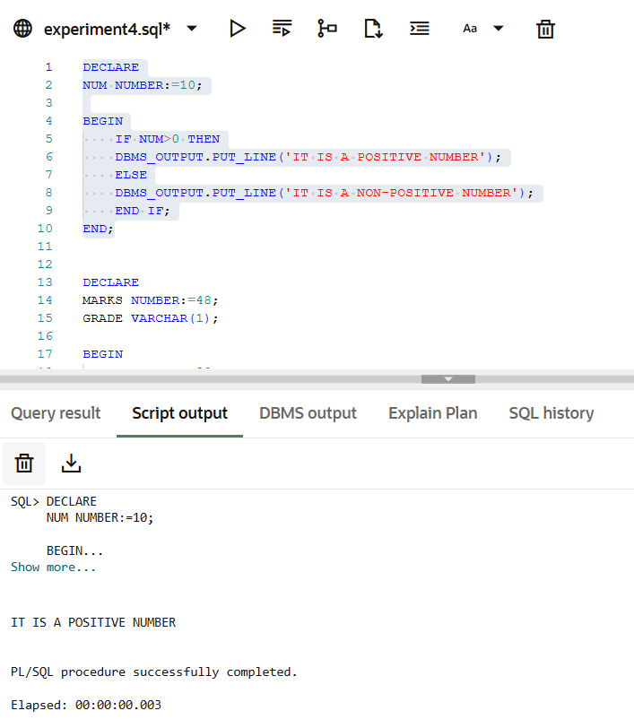

SQL Queries Input
DECLARE
MARKS NUMBER:=63;
GRADE VARCHAR(1);

BEGIN
IF MARKS>=90 THEN
GRADE:='A';
ELSIF MARKS>=80 THEN
GRADE:='B';
ELSIF MARKS>=70 THEN
GRADE:='C';
ELSIF MARKS>=60 THEN
GRADE:='D';
ELSE
GRADE:='F';
END IF;

DBMS_OUTPUT.PUT_LINE('MARKS = '||MARKS||', GRADE = '||GRADE);

END;

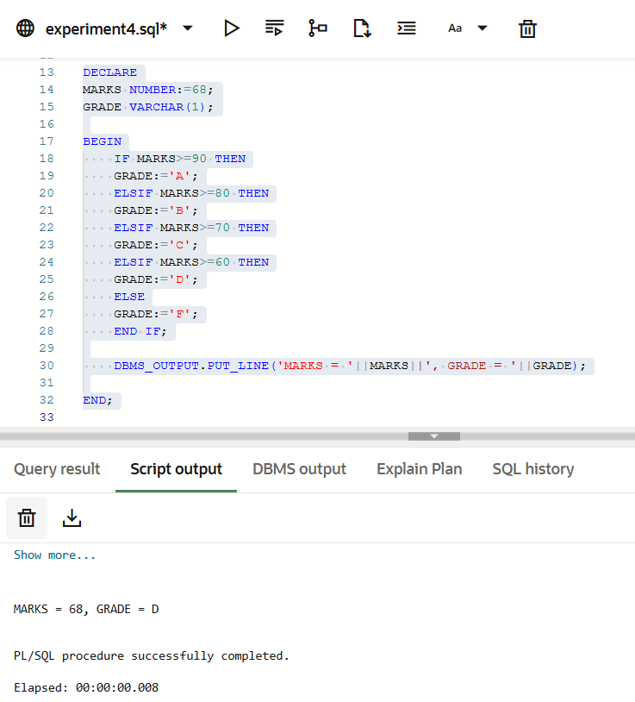
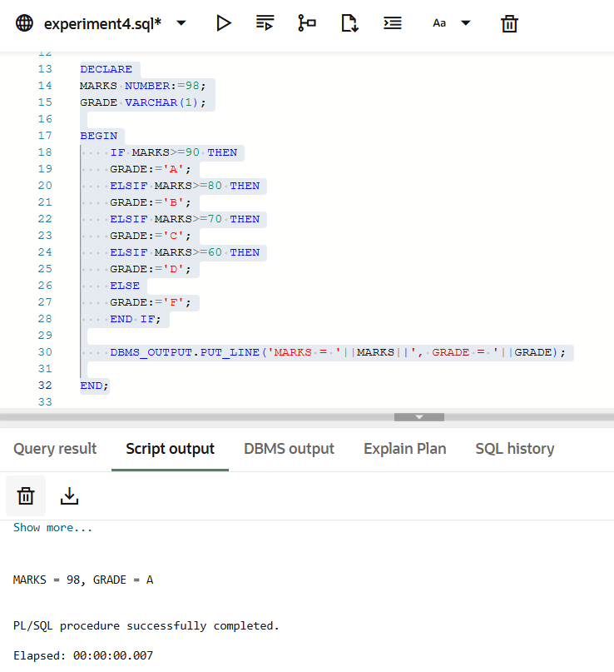
Output

SQL Queries Input
DECLARE
MARKS NUMBER:=58;
PERFORMANCE VARCHAR(20);

BEGIN
IF MARKS>=75 THEN
PERFORMANCE:='DISTINCTION';
ELSIF MARKS>=60 THEN
PERFORMANCE:='FIRST CLASS';
ELSIF MARKS>=50 THEN
PERFORMANCE:='SECOND CLASS';
ELSIF MARKS>=35 THEN
PERFORMANCE:='PASS';
ELSE
PERFORMANCE:='FAIL';
END IF;

DBMS_OUTPUT.PUT_LINE('MARKS = '||MARKS||' AND PERFORMANCE = '||PERFORMANCE);
END;

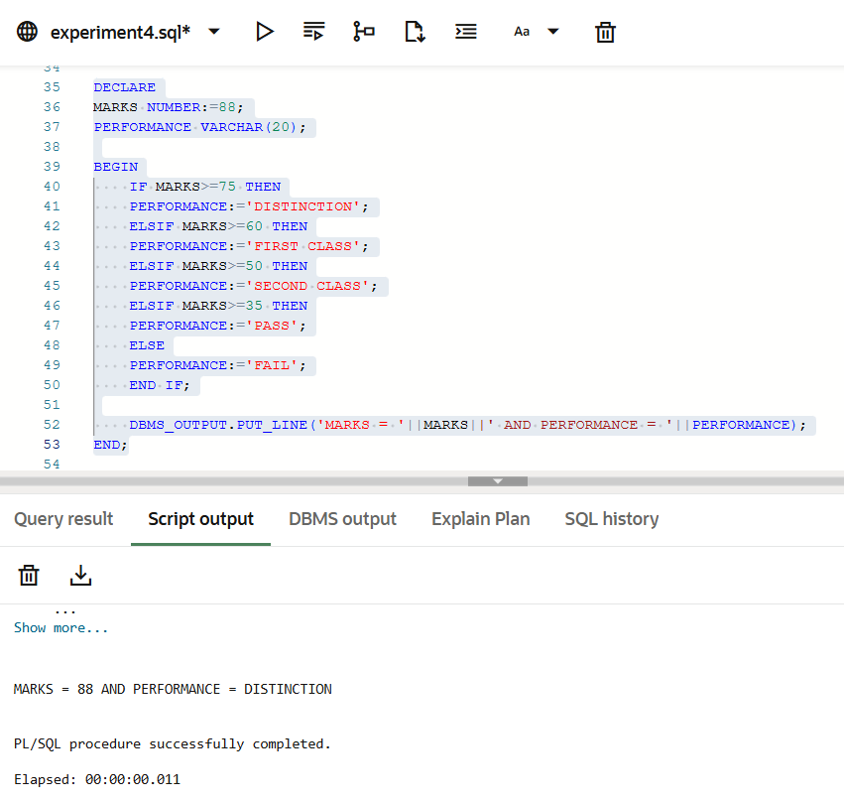
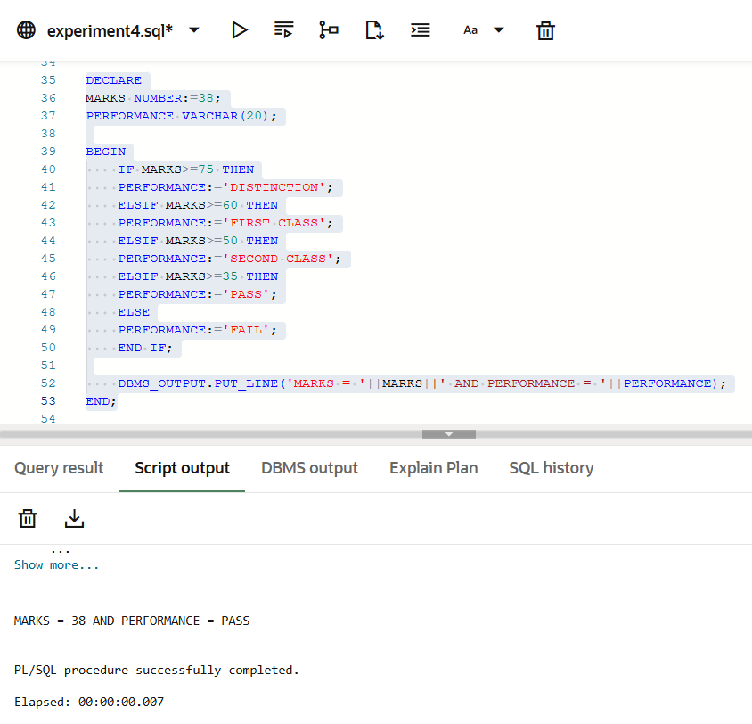
Output

SQL Queries Input
DECLARE
DAYNUM NUMBER:=5;
DAYNAME VARCHAR(20);

BEGIN
DAYNAME:=CASE DAYNUM
WHEN 1 THEN 'SUNDAY'
WHEN 2 THEN 'MONDAY'
WHEN 3 THEN 'TUESDAY'
WHEN 4 THEN 'WEDNESDAY'
WHEN 5 THEN 'THURSDAY'
WHEN 6 THEN 'FRIDAY'
WHEN 7 THEN 'SATURDAY'
ELSE 'INVALID DAY'
END;

DBMS_OUTPUT.PUT_LINE('IT IS '||DAYNAME);
END;

Output

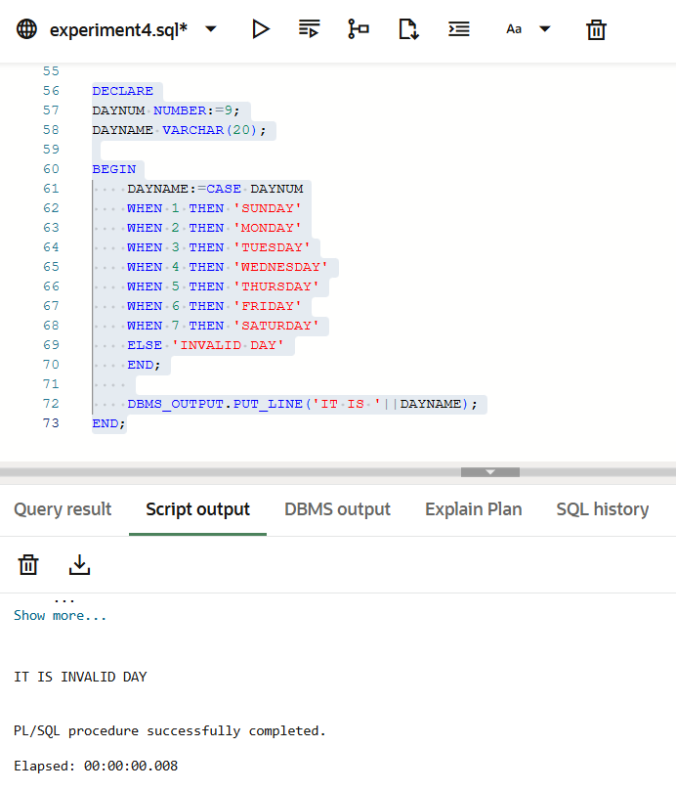
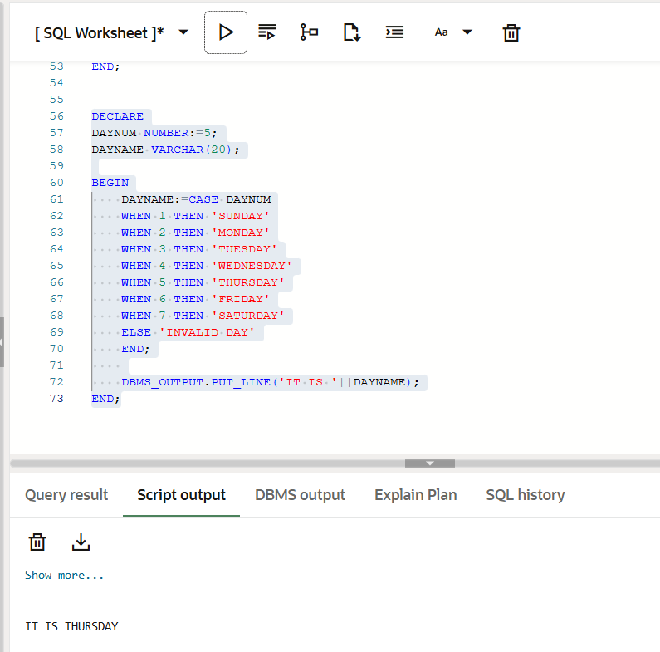

Learning Outcomes
- Gained proficiency in using IF-ELSE, ELSIF ladders, and CASE statements to control program execution flow.
- Evaluated data variables to automate specific outcomes, such as student grading or performance status.
- Using CASE statements as a streamlined method for mapping discrete values like day numbers to names.
- Skills in setting logical thresholds to categorize raw numerical marks into descriptive classifications

